Day 18 EMP ID = 1129116146

Task 1 👍
Chaining using LinkedList

Task 5 👍

Radix Sort (LSD — Least Significant Digit first)

Radix Sort Algo:
1.Check if all the input elements have same number of digits.
If not, check numbers that have maximum number of digits in the list and add leading zeroes to the ones that do not.

2. Take the least significant digit/units digit of each element.

3. Sort these digits using counting sort logic and try to change the order of elements depending on the output achieved.

Sample: if input elements are decimal numbers, possible values each digit can take would be 0-9, so index the digits based on these values.

4. Repeat step 2 for next least significant digits until all digits in given elements are sorted.

5. The final list of elements achieved after kth loop is the sorted output.

Task6 :

FUNCTION countSort(arr[], n, place):
CREATE output[0..n–1]
CREATE count[0..9] INITIALIZED TO 0

// Count occurrences of each digit at 'place'
FOR i = 0 TO n–1 DO
digit ← (arr[i] / place) % 10
count[digit] ← count[digit] + 1

// Cumulative counts for positions
FOR d = 1 TO 9 DO
count[d] ← count[d] + count[d – 1]

// Build output array backwards (stable)
FOR i = n–1 DOWNTO 0 DO
digit ← (arr[i] / place) % 10
output[count[digit] – 1] ← arr[i]
count[digit] ← count[digit] – 1

// Copy sorted items back
FOR i = 0 TO n–1 DO
arr[i] ← output[i]
END FUNCTION

Task 7

import java.util.ArrayList;
import java.util.Arrays;
import java.util.List;

public class Task7 {
public static void radixSort(int[] arr) {
int max = Arrays.stream(arr).max().orElse(0); // find largest number
int place = 1;
while (max / place > 0) {
// 10 buckets for digits 0–9
List<Integer>[] buckets = new ArrayList[10];
for (int i = 0; i < 10; i++) buckets[i] = new ArrayList<>();

// place each number in the right bucket based on current digit
for (int x : arr) {
int digit = (x / place) % 10;
buckets[digit].add(x);
}

// gather numbers back into array in bucket order
int idx = 0;
for (List<Integer> bucket : buckets) {
for (int x : bucket) {
arr[idx++] = x;
}
}
place *= 10;
}
}

public static void main(String[] args) {
int[] arr = {170, 45, 75, 90, 802, 24, 2, 66};
System.out.println("Before: " + Arrays.toString(arr));
radixSort(arr);
System.out.println("After: " + Arrays.toString(arr));
}

}

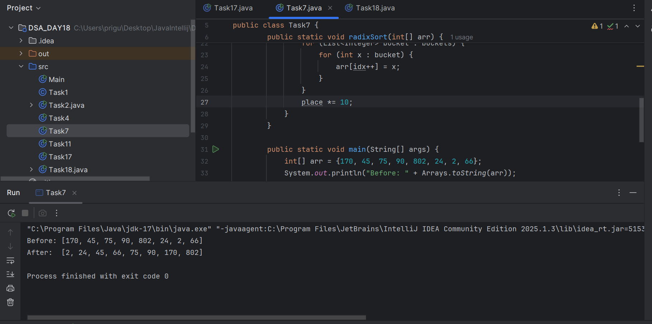

Kindly ignore this
import java.util.ArrayList;
import java.util.Arrays;
import java.util.List;

public class Task7 {
public static void radixSort(int[] arr) {
int max = Arrays.stream(arr).max().orElse(0); // find largest number
int place = 1;
while (max / place > 0) {
// 10 buckets for digits 0–9
List<Integer>[] buckets = new ArrayList[10];
for (int i = 0; i < 10; i++) buckets[i] = new ArrayList<>();

// place each number in the right bucket based on current digit
for (int x : arr) {
int digit = (x / place) % 10;
buckets[digit].add(x);
}

// gather numbers back into array in bucket order
int idx = 0;
for (List<Integer> bucket : buckets) {
for (int x : bucket) {
arr[idx++] = x;
}
}
place *= 10;
}
}

public static void main(String[] args) {
int[] arr = {170, 45, 75, 90, 802, 24, 2, 66};
System.out.println("Before: " + Arrays.toString(arr));
radixSort(arr);
System.out.println("After: " + Arrays.toString(arr));
}

}

Task 8 (MCQ)

will it achieve same result but emphasizes on recursive style using the same level-order logic with explicit queue management?

Task 9
“Memoization” is a technique in which we
- Store the results of expensive function calls (usually in a table or dictionary).
- Look up these results when the same input occurs again.
- Return the stored value instantly—no recomputation needed.

Example: Fibonacci Sequence
The Fibonacci sequence is a classic example where memoization can optimize performance. The sequence is defined as:
- F(0) = 0
- F(1) = 1
- F(n) = F(n-1) + F(n-2) for n > 1
With memoization, each value is computed once and stored for future use, reducing the time complexity to linear.

Task 10.

DP = Divide Problem ko in smaller parts + store results of these parts + and do not repeat for same calculation.
If same calculation is required , we can use DP./
There are two ways to do this :
- Memoization (Top-Down) = recursion + caching
- Tabulation (Bottom-Up) = iterative table filling
Task 11

public class Task11 {

public static void main(String[] args) {
int n = 10; // Calculate Fibonacci series up to the 10th number
int[] fib = new int[n + 1];

// Base cases
fib[0] = 0;
fib[1] = 1;

// Calculate Fibonacci numbers from 2 to n
for (int i = 2; i <= n; i++) {
fib[i] = fib[i - 1] + fib[i - 2];
}

// Print the Fibonacci series
System.out.println("Fibonacci series up to " + n + "th number:");
for (int i = 0; i <= n; i++) {
System.out.print(fib[i] + " ");
}
}

}

Task 13

. The system call stack tracks local variables and return addresses for each recursive invocation.

Task 14

The correct answer is 4. Multiple values are stored in same bucket via chaining.

Explanation
Your HashCollision class uses separate chaining to handle hash collisions. Here’s how it works:
- Each bucket in the table is a List<Entry>, allowing multiple key/value pairs to be stored under the same array index.
When a new key is inserted, it's hashed to an index:
java
CopyEdit
int index = Math.abs(key.hashCode() % table.size());

- If that bucket already contains entries (i.e., multiple keys hashed there), your code simply adds the new Entry to the list — storing multiple values in the same bucket.

Task 17

import java.util.*;
public class Task17 {

static class Node {
int data;
Node left, right;
Node(int d) { data = d; }
}

public static void printExtremeCorners(Node root) {
if (root == null) return;
Queue<Node> q = new LinkedList<>();
q.add(root);

while (!q.isEmpty()) {
int levelSize = q.size();
for (int i = 0; i < levelSize; i++) {
Node curr = q.poll();

// If it's the first or last node in this level, print it
if (i == 0 || i == levelSize - 1) {
System.out.print(curr.data + " ");
}

if (curr.left != null) q.add(curr.left);
if (curr.right != null) q.add(curr.right);
}
}
}

public static void main(String[] args) {
Node root = new Node(11);
root.left = new Node(22);
root.right = new Node(33);
root.left.left = new Node(66);
root.left.right = new Node(12);
root.right.left = new Node(16);
root.right.right = new Node(77);

System.out.print("Extreme corners: ");
printExtremeCorners(root);
}
}

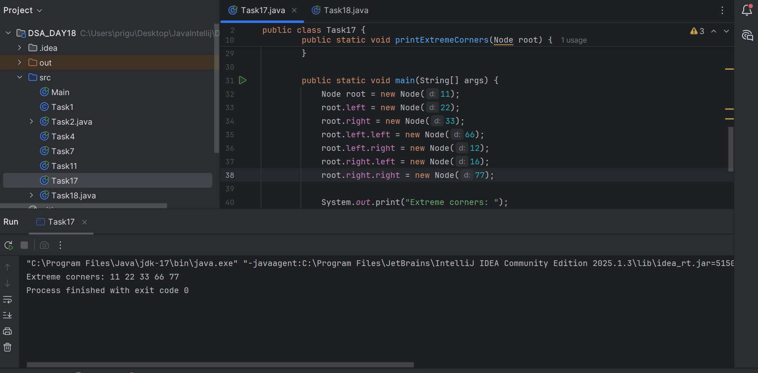

Task 18

import java.util.*;

class Node {
char data;
Node left, right;
Node(char c) { data = c; }
}

public class Task18 {

public static void reverseAlternate(Node root) {
if (root == null) return;

Queue<Node> queue = new LinkedList<>();
queue.offer(root);
int level = 0;

while (!queue.isEmpty()) {
int sz = queue.size();
List<Node> curr = new ArrayList<>();

for (int i = 0; i < sz; i++) {
Node node = queue.poll();
curr.add(node);

if (node.left != null) queue.offer(node.left);
if (node.right != null) queue.offer(node.right);
}

// Reverse on alternate (odd) levels
if (level % 2 == 1) {
int i = 0, j = curr.size() - 1;
while (i < j) {
char tmp = curr.get(i).data;
curr.get(i).data = curr.get(j).data;
curr.get(j).data = tmp;
i++; j--;
}
}

level++;
}
}

static void printInorder(Node root) {
if (root == null) return;
printInorder(root.left);
System.out.print(root.data + " ");
printInorder(root.right);
}

public static void main(String[] args) {
Node root = new Node('A');
root.left = new Node('B');
root.right = new Node('C');
root.left.left = new Node('D');
root.left.right = new Node('E');
root.right.left = new Node('F');
root.right.right = new Node('G');

System.out.print("Before inorder: ");
printInorder(root);
System.out.println();

reverseAlternate(root);

System.out.print("After inorder: ");
printInorder(root);
System.out.println();
}
}
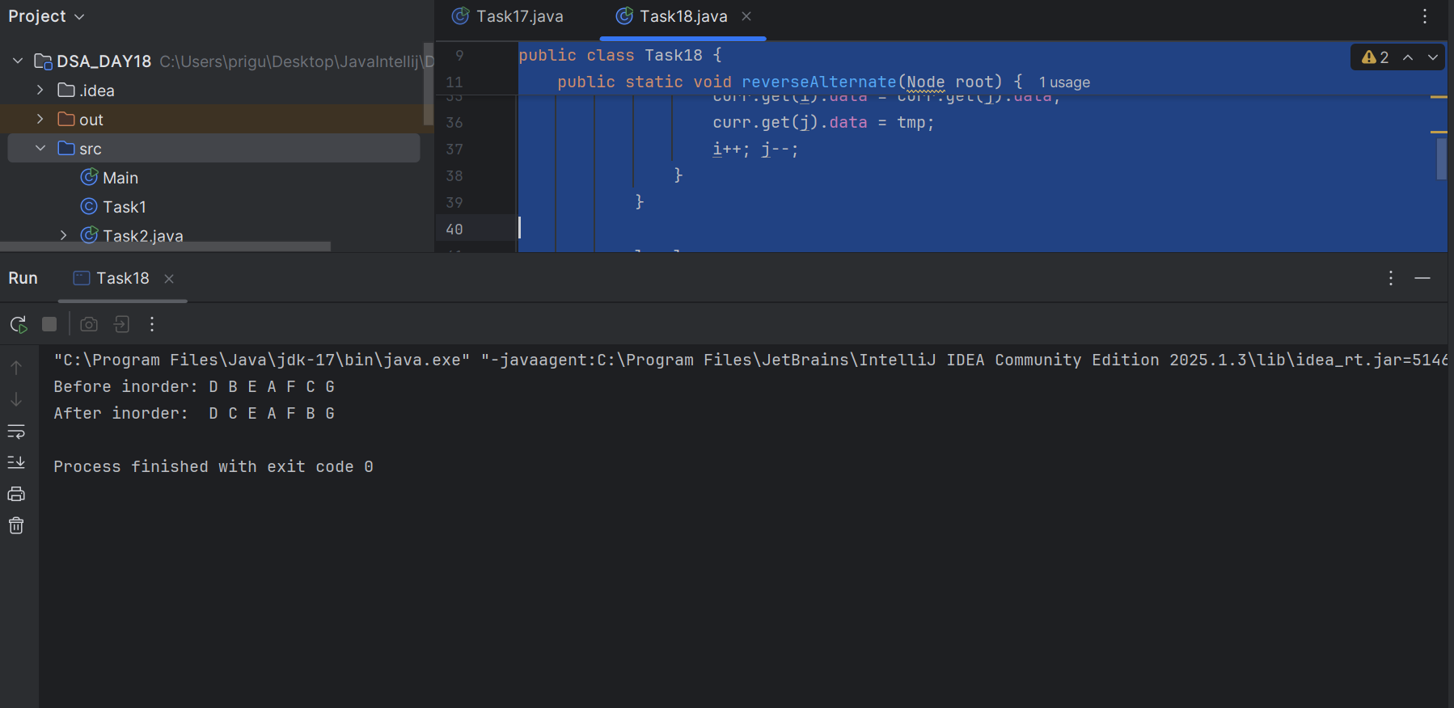

Task 19

/**
* Definition for a binary tree node.
* public class TreeNode {
* int val;
* TreeNode left;
* TreeNode right;
* TreeNode() {}
* TreeNode(int val) { this.val = val; }
* TreeNode(int val, TreeNode left, TreeNode right) {
* this.val = val;
* this.left = left;
* this.right = right;
* }
* }
*/
class Solution {
public List<Integer> rightSideView(TreeNode root) {

List<Integer> result = new ArrayList<>();
if (root == null) return result;

Queue<TreeNode> queue = new ArrayDeque<>();
queue.add(root);

while (!queue.isEmpty()) {
int size = queue.size();
for (int i = 0; i < size; i++) {
TreeNode node = queue.poll();
if (i == size - 1) {
result.add(node.val);
}
if (node.left != null) queue.add(node.left);
if (node.right != null) queue.add(node.right);
}
}
return result;
}

}

